**Capstone Project Prep 1 Part 2.**

**Case study on Online agriculture products store**

Mr. Henry, after being successful as a businessman and has become one of the wealthiest persons in the city. Now, Mr. Henry wants to help others to fulfil their dreams. One day, Mr. Henry went to meet his childhood friends Peter, Kevin and Ben. They live in a remote village and do farming. Mr. Henry asked his friends if they are facing any difficulties in their day-to-day work. Peter told Mr. Henry that he is facing difficulties in procuring fertilizers which are very important for farm. Kevin said that he is also facing the same problem in-case of buying seeds for farming certain crops. Ben raised his concern on lack of pesticides which could help in greatly reducing pests in crops. After listening to all his friends’ problems, Mr. Henry thought that this is a crucial problem faced not only by his friends but also by so many other farmers. So, Mr. Henry decided to make an online agriculture product store to facilitate remote area farmers to buy agriculture products. Through this Online Web / mobile Application, Farmers and Companies (Fertilizers, seeds and pesticides manufacturing Companies) can communicate directly with each other. The main purpose to build this online store is to facilitate farmers to buy seeds, pesticides, and fertilizers from anywhere through internet connectivity. Since new users are involved, Application should be user friendly. This new application should be able to accept the product (fertilizers, seeds, pesticides) details from the manufacturers and should be able to display them to the Farmers. Farmers will browse through these products and select the products what they need and request to buy them and deliver them to farmers location. Mr. Henry has given this project through his Company SOONY. In SOONY Company, Mr Pandu is Financial Head and Mr Dooku is Project Coordinator. Mr. Henry, Mr Pandu, and Mr Dooku formed one Committee and gave this project to APT IT SOLUTIONS company for Budget 2 Crores INR and 18 months Duration under CSR initiative. Peter, Kevin and Ben are helping the Committee and can be considered as Stakeholders share requirements for the Project. Mr Karthik is the Delivery Head in APT IT SOLUTIONS company and he reached out to Mr Henry through his connects and Bagged this project. APT IT SOLUTIONS company have Talent pool Available for this Project. Mr Vandanam is project Manager, Ms. Juhi is Senior Java Developer, Mr Teyson, Ms Lucie, Mr Tucker, Mr Bravo are Java Developers. Network Admin is Mr Mike and DB Admin is John. Mr Jason and Ms Alekya are the Tester. And you joined this team as a BA.

**Capstone prep 1 (Part 2)**

**Question 1)**

**4 Quarterly Audits are planned Q1, Q2, Q3, Q4 for this Project What is your knowledge on how these Audits will happen for a BA?**

**Ans:** The Audit is systematic examination of the procedure with along with the established rules, standards and criteria. The internal audits are ensure that to document audit report which may includes findings, recommendations and action plans. For this project the internal audits which are planned in 4 quarters as a BA perspective can be followings:

**Quarter 1 Documentation:**

1. Completeness:

* Are all required documents created and maintained?
* Do the documents cover all relevant aspects of the project?

1. Accuracy:

* Are the details in the documents correct and free from errors?
* Have the documents been reviewed and approved by relevant stakeholders?

1. Clarity and Readability:

* Are the documents written in a clear and understandable manner?
* Do the documents use language that is appropriate for the audience?

1. Consistency:

* Are the documents consistent in terms of format, style, and terminology?
* Do the documents align with the organization's documentation standards?

1. Relevance:

* Do the documents address the project's objectives and requirements?
* Are the documents up-to-date and reflective of the current project status?

1. Traceability:

* Is there traceability between requirements, design, and other project artifacts?
* Can changes to requirements and design be tracked and understood?

1. Accessibility:

* Are the documents easily accessible to relevant stakeholders?
* Is there a clear process for storing, retrieving, and managing the documents?

1. Compliance:

* Do the documents comply with relevant standards, regulations, and best practices?
* Have any deviations from standards been appropriately justified and documented?

**Capstone prep 1 (Part 2)**

**Quarter 2 Stakeholder’s Communication**

1. Meeting Preparation:

* Does the BA prepare adequately for stakeholder meetings, including setting agendas and identifying key objectives?
* Are meeting materials (e.g., presentations, documents) prepared and distributed in advance?

1. Meeting Facilitation:

* Does the BA effectively facilitate stakeholder meetings, ensuring all relevant topics are discussed and all participants are engaged?
* Does the BA manage meeting time efficiently to cover all agenda items?

1. Stakeholder Engagement:

* Does the BA actively engage with stakeholders to gather feedback, requirements, and expectations?
* Is there evidence of effective communication and collaboration with stakeholders?

1. Feedback Management:

* Does the BA capture and document stakeholder feedback accurately and comprehensively?
* Are there processes in place to address and incorporate feedback into project deliverables?

1. Conflict Resolution:

* Does the BA effectively manage conflicts that arise during stakeholder meetings or collaborations?
* Are conflicts resolved in a manner that maintains positive relationships with stakeholders?

1. Decision-making Support:

* Does the BA provide stakeholders with the information and analysis needed to make informed decisions?
* Is there evidence of stakeholders making decisions based on BA-provided insights?

1. Follow-up and Action Items:

* Does the BA follow up on action items and commitments made during stakeholder meetings?
* Are stakeholders kept informed of progress on action items?

**Capstone prep 1 (Part 2)**

**Quarter 3 Timesheet**

1. Accuracy:

* Are timesheets filled out accurately, reflecting actual time spent on project-related activities?
* Do timesheets match reported progress and deliverables?

1. Completeness:

* Are timesheets filled out completely, including all relevant project activities and time spent?
* Are timesheets submitted on time and in accordance with project timelines?

1. Consistency:

* Are timesheets consistent in terms of format, style, and content?
* Do timesheets adhere to the organization's time tracking policies and guidelines?

1. Approval Process:

* Is there a formal process for reviewing and approving timesheets?
* Are timesheets approved by the appropriate stakeholders in a timely manner?

1. Documentation:

* Are timesheets properly documented and stored for future reference?
* Is there a clear process for accessing and retrieving timesheet information?

1. Compliance:

* Do timesheets comply with relevant laws, regulations, and organizational policies?
* Are there any instances of non-compliance, and if so, how are they addressed?

1. Efficiency:

* Are timesheets easy to fill out and understand?
* Is the time tracking process efficient and not overly burdensome for stakeholders?

1. Reporting:

* Are timesheet reports generated and distributed regularly?
* Do timesheet reports provide useful insights into project progress and resource allocation?

**Quarter 4 Mailing Format**

1. Clarity and Professionalism:

* Are emails and other communications clear, concise, and professional?
* Is the language used appropriate for the intended audience?

1. Relevance and Completeness:

* Do emails contain all necessary information and attachments?
* Are communications relevant to the recipients and the context of the project?

1. Timeliness:

* Are emails and communications sent in a timely manner?
* Is there a prompt response to emails received from stakeholders?

1. Format and Structure:

* Are emails well-structured with appropriate subject lines, salutations, and signatures?
* Are complex messages broken down into clear, digestible parts?

1. Consistency:

* Are communications consistent in tone and format across different stakeholders and contexts?
* Do emails adhere to the organization's standard communication protocols?

1. Documentation and Record-Keeping:

* Are emails and communications properly archived and documented for future reference?
* Is there a system in place for organizing and retrieving past communications?

1. Confidentiality and Security:

* Are sensitive and confidential information communicated securely?
* Are appropriate measures taken to protect the confidentiality of stakeholders' information?

1. Feedback and Follow-up:

* Is there a mechanism for stakeholders to provide feedback on communications?
* Are follow-up actions clearly defined and tracked?

**Capstone prep 1 (Part 2)**

**Question 2) BA Approach Strategy**

1. **Elicitation Techniques**

* To gather requirements and ensure a comprehensive understanding of the project, I will utilize a combination of the following elicitation techniques:
  + Interviews: Conduct one-on-one interviews with key stakeholders including Mr. Henry, Mr. Pandu, Mr. Dooku, and Mr. Karthik to gather detailed requirements.
  + Workshops**:** Organize workshops involving stakeholders and project team members to collaboratively identify and prioritize requirements.
  + Surveys/Questionnaires: Distribute surveys to a broader group of stakeholders to gather a wide range of input.
  + Observation: Observe the current processes and workflows in the agricultural domain to understand pain points and opportunities.
  + Document Analysis: Review existing documentation related to the current processes, systems, and any prior attempts at similar projects.

1. **Stakeholder Analysis**

* Conduct a stakeholder analysis to identify all individuals and groups affected by the project. I will use a RACI (Responsible, Accountable, Consulted, Informed) matrix to clarify roles and responsibilities:
  + Responsible (R): Mr. Karthik, Ms. Juhi, Java Developers, Network Admin, DB Admin, Testers, BA (You)
  + Accountable (A): Mr. Vandanam (Project Manager)
  + Consulted (C): Mr. Henry, Mr. Pandu, Mr. Dooku
  + Informed (I): All stakeholders

1. **Documents to Write**

* The following documents will be prepared throughout the project:
  + Business Requirements Document (BRD): Detailed requirements gathered from stakeholders.
  + Functional Requirements Document (FRD): Specific functionalities needed to meet the business requirements.
  + Use Case Specifications: Detailed descriptions of how the system will be used.
  + Wireframes and Prototypes: Visual representations of the user interface and user experience.
  + Test Plan and Test Cases: Detailed testing strategies and specific test cases.
  + Change Request Document: Record and manage changes to the project scope.
  + Project Status Reports: Regular updates on the project’s progress.
  + UAT Plan: Plan for User Acceptance Testing.

**Capstone prep 1 (Part 2)**

1. **Process for Document Sign-off**

* Draft Preparation: Prepare the initial draft of the document.
* Internal Review: Conduct an internal review with the project team and incorporate feedback.
* Stakeholder Review: Share the document with stakeholders for their review and feedback.
* Revision: Make necessary revisions based on stakeholder feedback.
* Final Approval: Obtain final sign-off from the stakeholders, ensuring that all concerns are addressed.

1. **Client Approvals**

* Regular Updates: Provide regular updates to the client through meetings and reports.
* Review Meetings: Schedule review meetings at key milestones to present progress and obtain approvals.
* Formal Sign-off: Obtain formal sign-off on key deliverables and milestones through the Client Project Acceptance Form.

1. **Communication Channels**

* Establish effective communication channels to ensure smooth information flow:
  + Email: For formal communication and documentation.
  + Meetings: Regularly scheduled meetings (e.g., weekly status meetings, monthly review meetings).
  + Project Management Tool: Use a project management tool like Jira for task tracking and collaboration.
  + **I**nstant Messaging**:** Use tools like Slack or Microsoft Teams for quick communication and collaboration.

1. **Handling Change Requests**

* Change Request Submission: Establish a process for submitting change requests.
* Impact Analysis: Conduct an impact analysis to assess the effect of the change on scope, timeline, and budget.
* Approval Process: Review and approve changes through a formal change control board (CCB).
* Documentation: Document all changes and update project documentation accordingly.
* Communication: Communicate approved changes to all stakeholders and update the project plan.

**Capstone prep 1 (Part 2)**

1. **Updating Project Progress**

* Status Reports: Prepare and distribute weekly and monthly status reports highlighting progress, risks, and issues.
* Meetings: Conduct regular status meetings with the project team and stakeholders.
* Dashboards: Use dashboards in the project management tool to provide real-time visibility into project progress.

1. **UAT and Client Project Acceptance**

* UAT Planning: Develop a UAT plan outlining the testing scope, objectives, and acceptance criteria.
* UAT Execution: Coordinate with testers and stakeholders to execute UAT.
* Issue Resolution: Track and resolve any issues identified during UAT.
* Sign-off: Obtain final sign-off on the UAT results through the Client Project Acceptance Form, ensuring that all acceptance criteria are met.

**Capstone prep 1 (Part 2)**

**Question 3) Explain and illustrate 3-tier architecture?**

**Ans: 3-Tier Architecture** is a software design pattern and a client-server architecture that divides applications into three distinct and interdependent layers: the Application Layer, the Business Logic Layer, and the Data Access Layer. Each layer is responsible for specific aspects of the application, promoting separation of concerns and improving scalability, maintainability, and flexibility.

**1. Application Layer**

Manages user interface and user interactions.

**Responsibilities:**

* Displays information to users.
* Captures user inputs.
* Sends user requests to the business logic layer.

**Components:**

* Web Browsers or Mobile Apps.
* UI Frameworks and Libraries

**Example:**

* Web page displaying a list of products.
* Form for user login and registration.

**2. Business Logic Layer**

Contains the core functionality and business rules of the application.

**Responsibilities**:

* Processes user inputs.
* Performs business operations and calculations.
* Enforces business rules.
* Handles application workflows.

**Components**:

* Application Server.
* Server-side Frameworks (e.g., Spring, Django, Express).

**Example**:

* Logic for processing a user order.
* Validations for user inputs.
* Calculations for pricing and discounts.

**Capstone prep 1 (Part 2)**

**3. Data Access Layer (Data Tier)**

Manages data storage, retrieval, and persistence.

**Responsibilities**:

* Interacts with the database.
* Performs CRUD operations (Create, Read, Update, Delete).
* Ensures data integrity and security.

**Components:**

* Database Management Systems (DBMS) (e.g., MySQL, PostgreSQL, MongoDB).
* Data Access Frameworks (e.g., Hibernate, Entity Framework).

**Example:**

* Storing user information in a database.
* Retrieving product details for display.

**Capstone prep 1 (Part 2)**

**Question 4) Business Analyst should keep What points in his/her mind before he frames a Question to ask to the Stakeholder (5W 1H – SMART – RACI – 3 Tier Architecture – Use Cases, Use case Specs, Activity Diagrams, Models, Page designs)**

**Ans:** As a BA for the Agricultural products store project, Following points can be take into consideration for ask questions to stakeholder/client by using tools such as 5W 1H – SMART – RACI – 3 Tier Architecture – Use Cases, Use case Specs, Activity Diagrams, Models, Page designs.

**1. 5W 1H Method**

This method helps ensure that all aspects of a topic are covered:

* **Who:** Identify who is involved or affected by the requirement or issue.

Example: "Who will be using this new feature?"

* **What**: Determine what the requirement or issue is.

Example: "What are the primary goals of this project?"

* **When**: Establish the timeline or deadlines.

Example: "When is this feature expected to be delivered?"

* **Where**: Understand the context or environment.

Example: "Where will this solution be implemented?"

* **Why**: Clarify the reasons or motivations.

Example: "Why is this change necessary?"

* **How**: Explore the methods or processes.

Example: "How will this solution improve current processes?"

**2. SMART** **Criteria**

Ensure the questions lead to Specific, Measurable, Achievable, Relevant, and Time-bound objectives:

* **Specific**: Focus on clear and precise aspects.

Example: "What specific problems are you encountering with the current system?"

* **Measurable**: Aim for quantifiable answers.

Example: "How many users are expected to use this feature?"

* **Achievable**: Ensure the goals discussed are realistic.

Example: "What resources do we have to implement this solution?"

* **Relevant**: Keep questions aligned with project goals.

Example: "How does this feature align with the project objectives?"

* **Time-bound:** Include a timeframe.

Example: "What is the expected timeline for this requirement?"

**3. RACI Framework**

Use RACI to understand roles and responsibilities:

* **Responsible:** Who is responsible for the task?

Example: "Who is responsible for approving the design?"

* **Accountable**: Who is accountable for the outcome?

Example: "Who will be accountable for the success of this feature?"

* **Consulted**: Who should be consulted for their input?

Example: "Who should we consult regarding user experience?"

* **Informed**: Who needs to be kept informed?

Example: "Who needs to be informed about the project milestones?"

**4. 3-Tier Architecture**

Consider the different layers of the system:

* **Application** **Layer:** Questions about the user interface and user experience.

Example: "What specific UI elements do you need?"

* **Business Logic Layer:** Questions about the business rules and processes.

Example: "What are the business rules governing this process?"

* **Data Access Layer:** Questions about data storage and retrieval.

Example: "What data needs to be captured and stored?"

**5. Use Cases and Specifications**

Frame questions to define use cases and detailed specifications:

* **Use Cases:** Questions to capture user interactions with the system.

Example: "Can you describe a typical use case for this feature?"

* **Use Case Specifications:** Detailed questions to specify each use case.

Example: "What are the preconditions and postconditions for this use case?"

* **Activity Diagrams:** Questions to map out processes.

Example: "Can you describe the workflow for this process?"

* **Models:** Questions to create models representing the system.

Example: "What data entities are involved in this process?"

* **Page Designs:** Questions about specific page layouts and functionality.

Example: "What information needs to be displayed on this page?"

**Capstone prep 1 (Part 2)**

**Question 5) As a Business Analyst, What Elicitation Techniques you are aware of? (BDRFOWJIPQU)**

**Ans:** As a Business Analyst, it is crucial to be familiar with various elicitation techniques to effectively gather requirements and insights from stakeholders as follows:

* **Brainstorming (B)**

**Description**: A group creativity technique designed to generate a large number of ideas for the solution to a problem.

**Use:** Useful in the early stages of a project to gather a wide range of ideas from stakeholders.

* **Document Analysis (D)**

**Description:** Reviewing existing documentation to gather requirements and understand the current state.

**Use:** Ideal for understanding existing systems, processes, and identifying gaps or areas for improvement.

* **Reverse Engineering (R)**

**Description:** Analysing an existing system or product to understand its components and functionality.

**Use:** Helpful when documentation is outdated or unavailable, to understand the system by deconstructing it.

* **Focus Groups (F)**

**Description:** A moderated discussion with a selected group of individuals to gather feedback and opinions on a specific topic.

**Use:** Effective for collecting qualitative data and understanding stakeholder perspectives.

* **Observation (O)**

**Description:** Watching how users interact with a system or process to gather insights.

**Use:** Useful for understanding the actual workflow and identifying inefficiencies or areas for improvement.

* **Workshops (W)**

**Description:** Structured group sessions that bring together stakeholders and subject matter experts to discuss and define requirements.

**Use:** Effective for detailed requirement gathering and achieving consensus among stakeholders.

* **JAD (Joint Application Development) Sessions (J)**

**Description:** Extended, collaborative workshops involving stakeholders and developers to define requirements and design solutions.

**Use:** Useful for complex projects where requirements need to be thoroughly discussed and agreed upon by all parties.

* **Interviews (I)**

**Description:** One-on-one or group interviews with stakeholders to gather detailed information.

**Use:** Effective for collecting in-depth insights and understanding individual stakeholder needs and concerns.

* **Prototyping (P)**

**Description:** Creating a preliminary version of a system or feature to gather feedback and refine requirements.

**Use:** Useful for visualizing requirements and receiving early validation from stakeholders.

* **Questionnaires and Surveys (Q)**

**Description**: Distributing a set of questions to a large group of stakeholders to collect information quickly.

**Use**: Ideal for gathering quantitative data and opinions from a wide audience.

* **Use Case Analysis (U)**

**Description**: Defining and analysing use cases to understand system interactions from the user’s perspective.

**Use**: Effective for identifying functional requirements and ensuring that all user scenarios are considered.

**Capstone prep 1 (Part 2)**

**Question 6) Which Elicitation Techniques can be used in this Project and Justify your selection of Elicitation Techniques? Prototyping, Use case Specs, Document Analysis, Brainstorming.**

**Identify Business Requirements (which includes Stakeholder Requirements)**

**Ans: Brainstorming**

Justification: Brainstorming sessions with key stakeholders like Peter, Kevin, and Ben will help generate a wide range of ideas and solutions for the project. This technique will be useful in the initial stages to gather high-level requirements and understand different perspectives. Brainstorming will also help in identifying potential challenges and exploring innovative features that could enhance the user experience.

**Business Requirements (including Stakeholder Requirements):**

**BR001**: Farmers should be able to search for available products in fertilizers, seeds, pesticides.

Stakeholder Requirement: Kevin emphasized the need for a search option so that farmers can easily find the products they need.

**BR002:** Manufacturers should be able to upload and display their products in the application.

Stakeholder Requirement: The application should support product catalog management for manufacturers, enabling them to update product details and availability.

**BR003:** The system should support user login and account creation.

Stakeholder Requirement: Peter mentioned that farmers need to log in to add products to their buy-later list or to make purchases. New users should be able to create accounts using their email ID and a secure password.

**BR004:** The system should provide a seamless payment process.

Stakeholder Requirement: Ben highlighted the importance of an easy-to-use payment gateway that includes COD, credit/debit card, and UPI options.

**BR005**: The system should send email confirmations regarding order status.

Stakeholder Requirement: Kevin mentioned the need for order status updates via email to keep users informed about their purchases.

**BR006**: The system should include a delivery tracker.

Stakeholder Requirement: Kevin also mentioned the need for a delivery tracking feature to help users monitor the status of their orders.

**Question 7) Make suitable Assumptions and identify at least 10 Business Requirements.**

**Ans: Business Requirements for Online agriculture product store project:**

**BR001: Search Functionality for Farmers**

Farmers should be able to search for available products in fertilizers, seeds, and pesticides using keywords.

**BR002: Product Catalog Management for Manufacturers**

Manufacturers should be able to upload, edit, and display their products in the application with detailed descriptions and images.

**BR003: User Authentication and Account Management**

The system should support user login and account creation with email ID and password. New users should be able to register, and existing users should be able to log in and manage their accounts.

**BR004: Product Browsing without Login**

Farmers should be able to browse through the product catalog without logging in but must log in to add items to their cart or make a purchase.

**BR005: Shopping Cart and Buy-Later List**

Farmers should be able to add products to a shopping cart and a buy-later list. They should be able to review, edit, and remove items from these lists before making a purchase.

**BR006: Payment Gateway Integration**

The system should integrate with multiple payment gateways to support various payment methods including COD, credit/debit cards, and UPI.

**BR007: Order Confirmation and Status Updates**

The system should send email confirmations to users regarding their order status, including order placement, processing, shipping, and delivery.

**BR008: Delivery Tracking System**

Farmers should be able to track the status of their orders in real-time through a delivery tracking feature integrated into the application.

**BR009: Product Reviews and Ratings**

Users should be able to leave reviews and ratings for products they have purchased to help other users make informed decisions.

**BR010: Promotions and Discounts**

The system should support the creation and application of promotional codes and discounts that can be used by farmers during the checkout process.

**Capstone prep 1 (Part 2)**

**Question 8) List your assumptions**

**Ans: Assumptions for Online agriculture product store project**

* **Internet Access:** Farmers in remote areas will have reliable internet access to use the online store.
* **Technical Literacy**: Farmers and manufacturers will have a basic understanding of how to use a web/mobile application.
* **Product Availability:** Manufacturers will have a steady supply of fertilizers, seeds, and pesticides to list on the platform.
* **Compliance:** All listed products will comply with local agricultural regulations and standards.
* **Security Measures:** Adequate security measures will be in place to protect user data and payment information.
* **Delivery Services:** Reliable delivery services will be available to ensure timely delivery of orders to farmers' locations.
* **Manufacturer Participation:** Manufacturers will be willing to participate and regularly update their product listings on the platform.
* **Customer Support:** There will be a dedicated customer support team to assist users with any issues or queries.
* **Financial Investment**: The project will stay within the allocated budget of 2 Crores INR over 18 months.
* **Stakeholder Engagement:** Key stakeholders, including Peter, Kevin, and Ben, will actively participate and provide valuable input throughout the project.

**Capstone prep 1 (Part 2)**

**Question 9) This project Requirements Priority**

|  |  |  |  |
| --- | --- | --- | --- |
| Req ID | Req Name | Req Description | Priority |
| BR001 | Farmer Search for Products | Farmers should be able to search for available products in fertilizers, seeds, pesticides | 9 |
| BR002 | Manufacturer Product Upload | Manufacturers should be able to upload and display their products in the application | 8 |
| BR003 | User Login | Farmers need to login using mobile no. and password to buy products or add them to buy-later list | 10 |
| BR004 | New User Registration | New users can create an account by submitting their mobile no and creating a secure password | 9 |
| BR005 | Easy-to-use Payment Gateway | Payment options should include COD, Credit/Debit card, and UPI | 10 |
| BR006 | Order Confirmation | Users should receive a message confirmation regarding their order status | 7 |
| BR007 | Delivery Tracking | A delivery tracker to track the whereabouts of orders | 8 |
| BR008 | Product Catalog Browsing | Farmers should be able to browse through the product catalog once they visit the website | 9 |
| BR009 | Secure Data Handling | Adequate security measures should be in place to protect user data and payment information | 10 |
| BR010 | Customer Support | A dedicated customer support team should be available to assist users with any issues or queries | 7 |

**Ans:**

**Question 10) Draw use case diagram**

**Ans:**

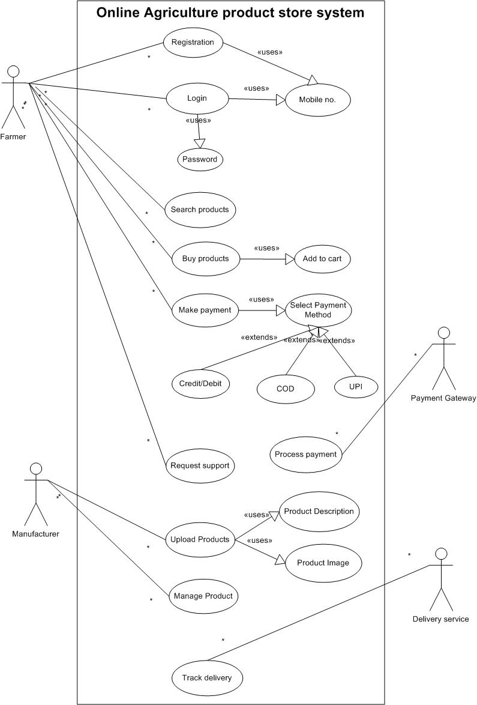

**Question 11) Prepare use case specs for all use cases**

**Ans:**

1. **Use Case Name:** User Registration

**Actor:** Farmer

**Description:** Farmer registers for an account.

**Preconditions:** Farmer has internet access.

**Postconditions:** Farmer account is created.

**Input:** User details (name, email, password).

**Output:** Registration confirmation.

**Constraints:** Unique email requirement.

**Business Rule:** One account per email.

**Alternative Flow:** User can reset password.

**Exceptional Flow:** Email already registered.

1. **Use Case Name:** Login

**Actor:** Farmer

**Description:** Farmer logs into the system.

**Preconditions:** User account exists.

**Postconditions:** Farmer accesses the dashboard.

**Input:** Username, password.

**Output:** Login success message.

**Constraints:** Secure password storage.

**Business Rule:** Account lockout after 3 failed attempts.

**Alternative Flow:** User resets forgotten password.

**Exceptional Flow:** Incorrect password

1. **Use Case Name:** Browse Products

**Actor:** Farmer

**Description:** Farmer browses available products.

**Preconditions:** User is logged in.

**Postconditions:** Products displayed.

**Input:** Search criteria.

**Output:** Product list.

**Constraints:** Real-time inventory updates.

**Business Rule:** Display only in-stock items.

**Alternative Flow: F**ilter products by category.

**Exceptional Flow:** No products match criteria.

1. **Use Case Name:** Add Product to Cart

**Actor:** Farmer

**Description:** Farmer adds a product to the cart.

**Preconditions:** Product is available.

**Postconditions:** Product added to cart.

**Input:** Product selection.

**Output:** Updated cart.

**Constraints:** Stock validation.

**Business Rule:** Limit per product.

**Alternative Flow:** Update product quantity in cart.

**Exceptional Flow:** Product out of stock.

1. **Use Case Name: Add Product**

**Actor:** Manufacturer

**Description:** Manufacturer adds a new product to the inventory.

**Preconditions:** Manufacturer is logged in.

**Postconditions:** Product added to the inventory.

**Input:** Product details (name, description, price, quantity).

**Output:** Product added confirmation.

**Constraints:** Product details validation.

**Business Rule:** Unique product identifier.

**Alternative Flow:** Edit existing product details.

**Exceptional Flow:** Invalid product details.

**Question 12) Activity Diagrams**

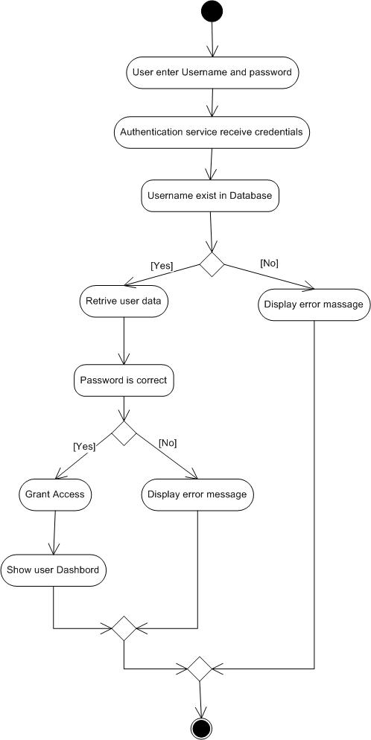**Ans: 1) User Login**

**2) Product Search**

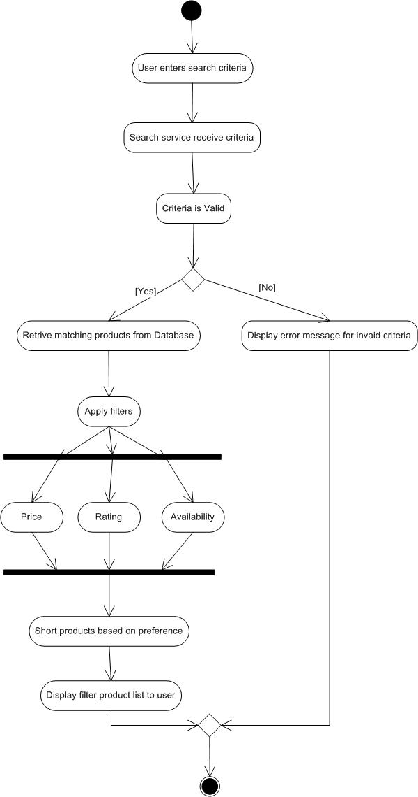

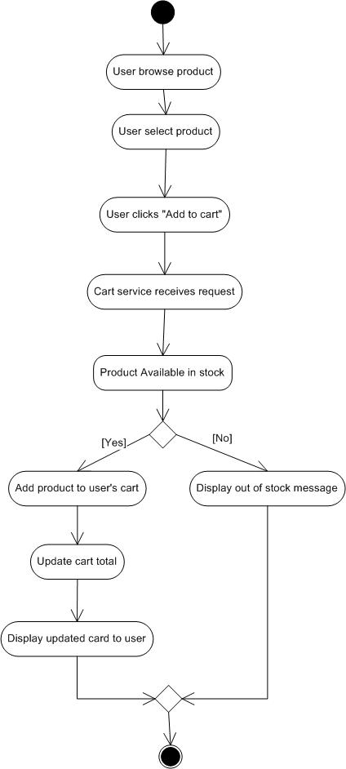**3) Add to cart**

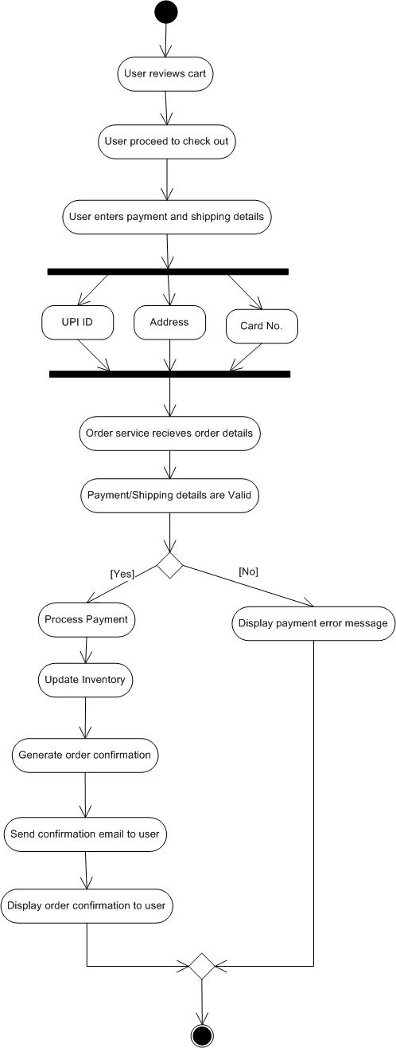**4) Buy product**

**5) Manufacturer upload products**

